**Practical - 4**

Implement a function of sequential search and count the steps executed by function on various inputs for best case and worst case. Also write complexity in each case and draw a comparative chart.

**Code:**

#include<stdio.h>

int count=0;

int linear(int k[],int n,int x)

{

int i;

count++;

for(i=0;i<n;i++)

{

count++;

if(k[i]==x)

{

count++;

return i;

}

}

count++;

return -1;

}

void main()

{

int k[100];

int n,x,a,i;

printf("19012011092 Abhishek V Jani\n");

printf("Enter Size of an Array:");

scanf("%d",&n);

for(i=0;i<n;i++)

{

k[i] = i+1;

}

printf("\nArray of Size=%d\n",n);

for(i=0;i<n;i++)

{

printf("%d ",k[i]);

}

printf("\nEnter Element to be searched:");

scanf("%d",&x);

a=linear(k,n,x);

if(a!=-1)

{

printf("\nElement %d is at Index %d",x,a);

printf("\nSteps=%d",count);

}

}

**Output:**

**1. Best Case:**

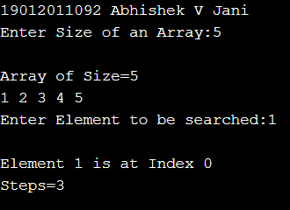

**2. Average Case:**

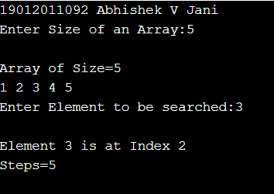

**3. Worst Case:**

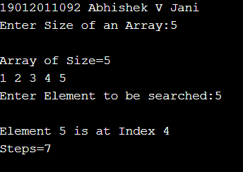

**Analysis:**

**1. Table:**

|  |  |  |  |
| --- | --- | --- | --- |
| n | Best case | Average Case | Worst Case |
| 5 | 3 | 5 | 7 |
| 10 | 3 | 7 | 12 |
| 15 | 3 | 10 | 17 |
| 20 | 3 | 12 | 22 |
| 25 | 3 | 14 | 27 |

**2. Graph:**

3. Time Complexity of Sequential Search:

For the Best Case: O(1)

Reason: Since the First element is being searched thus there will be no further comparison.

For the Average and Worst Case: O(n)

Reason:

* The element being searched may be present at the last position or not present in the array at all.
* In the former case, the search terminates in success with n comparisons.
* In the later case, the search terminates in failure with n comparisons.
* Thus in worst case, linear search algorithm takes O(n) operations.
* In Average Case it tooks n comparison to find element thus it takes O(n) operations.

**Conclusion:**

Linear Search is one of the easiest search algorithm which is very efficient when the element is to be search in small sized array. It works on both Sorted and Unsorted Array. But when the element is to be searched in larged size array, this searching technique should be not used as it takes lots of time and steps in comparison. Thus Linear Search is not efficient for large sized Array.